# Emotional Permutation Framework

## Theory Proof

### Proto Encryption and Universal Symbology

Proto Encryption is an advanced encryption technique that leverages Universal Symbology and quantum computing principles to provide robust security for data and communications. This theory proof outlines the mathematical and computational foundations of Proto Encryption, demonstrating its efficacy and security through a series of logical and theoretical steps. By integrating Universal Symbology with quantum-resistant algorithms, Proto Encryption offers a future-proof solution to the challenges posed by both classical and quantum computing attacks.

### 1. Introduction

#### 1.1 Overview

Proto Encryption is designed to secure data through the use of a unique symbology system and quantum computing principles. Universal Symbology provides a standardized and efficient way to encode data, while quantum-resistant algorithms ensure that the encryption remains secure against potential quantum computing threats.

#### 1.2 Objectives

This theory proof aims to:

1. Define the mathematical foundations of Universal Symbology.

2. Demonstrate the process of encoding data using Universal Symbology.

3. Outline the implementation of quantum-resistant encryption algorithms.

4. Prove the security and robustness of Proto Encryption.

### 2. Mathematical Foundations of Universal Symbology

#### 2.1 Symbol Set and Representation

Universal Symbology uses a finite set of symbols, each representing a unique piece of data. Let  be the set of universal symbols, such that:

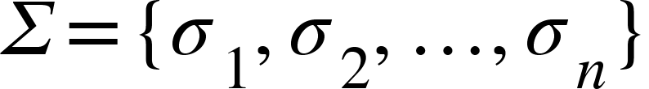

Each symbol 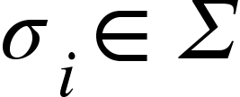 corresponds to a specific data element, allowing for clear and unambiguous representation.

#### 2.2 Encoding Data

Data  can be represented as a sequence of symbols from . Let 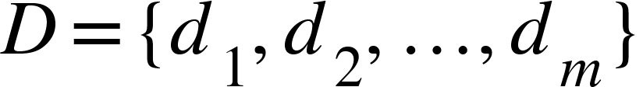 be a data sequence, where each 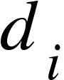 is mapped to a symbol 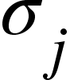 in .

The encoding function  maps data elements to their corresponding symbols:

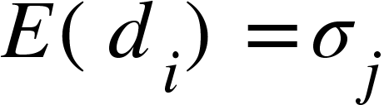

This creates an encoded data sequence 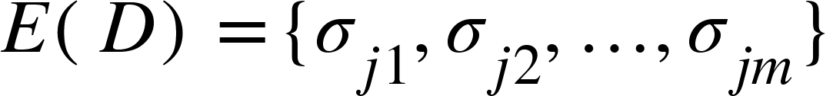.

#### 2.3 Symbolic Permutations and Transformations

Universal Symbology also supports symbolic permutations and transformations, which enhance the flexibility and security of the encoding process. Let 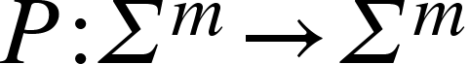 be a permutation function that reorders symbols based on specific rules:



These transformations ensure that even if the data pattern is predictable, the encoded sequence remains unpredictable.

#### 2.4 Symbolic Operations and Mathematical Functions

Universal Symbology extends beyond simple encoding by allowing for symbolic operations and mathematical functions. These operations enable complex data transformations and calculations, making the encoded data versatile and adaptable for various applications.

Let 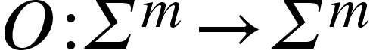 be a symbolic operation applied to the encoded data sequence:



By applying symbolic operations, Universal Symbology can represent complex data manipulations, enhancing the utility and security of the encoded information.

### 3. Quantum-Resistant Encryption Algorithms

#### 3.1 Quantum Gates and Circuits

Quantum computing relies on quantum gates and circuits to perform operations on qubits. Let  be a quantum circuit consisting of a set of qubits 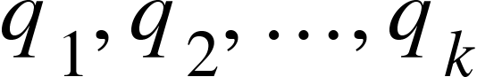 and quantum gates .

A quantum gate 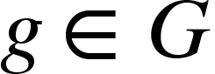 operates on qubits to transform their states. Common gates include:

* **Hadamard Gate (H)**: Creates superposition:

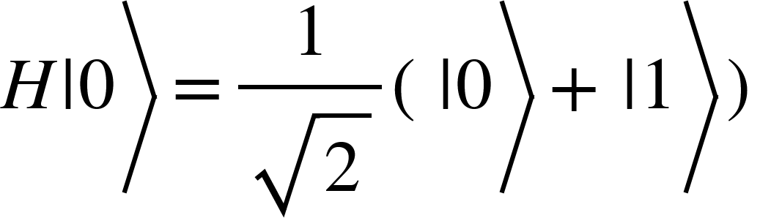

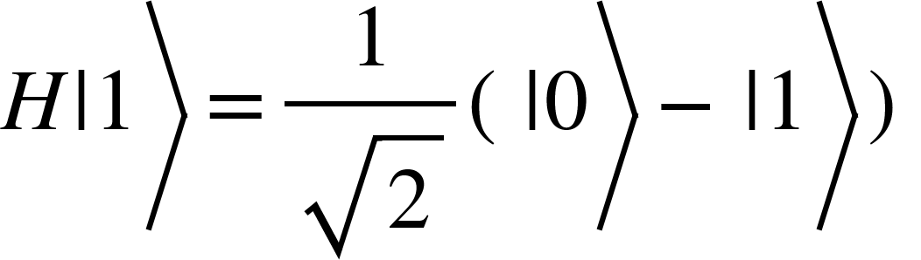

* **Pauli-X Gate (X)**: Flips the state:

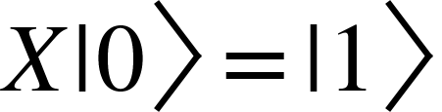

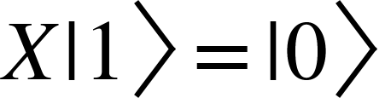

* **Controlled-NOT Gate (CNOT)**: Entangles qubits:

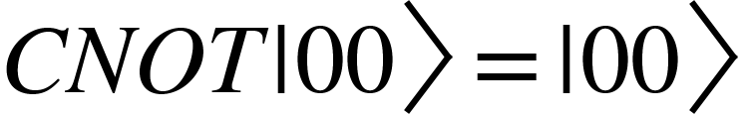

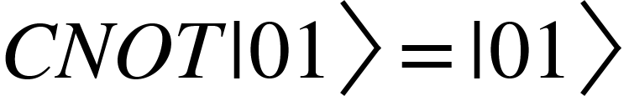

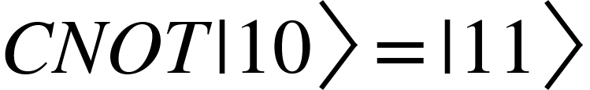

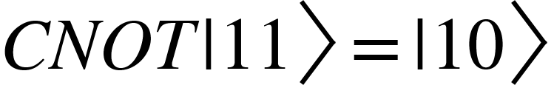

#### 3.2 Quantum-Resistant Encryption

Quantum-resistant encryption involves creating an encrypted state that is secure against both classical and quantum attacks. Let  be the encryption key generated using quantum key distribution (QKD) methods.

The encryption function  maps the encoded data sequence and key to a quantum state:



This quantum state  represents the encrypted data.

### 4. Security Proof

#### 4.1 Quantum Key Distribution (QKD)

QKD ensures that the encryption key  remains secure during transmission. Using QKD protocols, such as BB84, the sender and receiver can securely generate and share a key. The BB84 protocol, for example, uses quantum bits (qubits) transmitted over a quantum channel, where any eavesdropping attempt would alter the state of the qubits and be detected.

#### 4.2 Quantum-Resistant Encryption

The encrypted quantum state  is secure against both classical and quantum attacks due to the inherent properties of quantum mechanics. Any attempt to measure or intercept the quantum state would disturb it, making eavesdropping detectable. Additionally, the superposition and entanglement of qubits provide an exponential increase in the complexity of decrypting the data without the correct key.

#### 4.3 Robustness and Tamper-Proofing

The use of Universal Symbology ensures that any unauthorized changes to the data can be easily detected. The encoding is tamper-proof, and the integrity of the data is maintained throughout the encryption and transmission processes. This robustness is achieved by applying symbolic permutations and transformations that scramble the data in a way that unauthorized modifications can be identified.

##### 4.3.1 Tamper-Proof Encoding with Universal Symbology

Universal Symbology’s encoding and permutation ensure tamper-proof data. Let  be an unauthorized transformation:



Any alteration  to the encoded data is detectable since the symbology and permutation create a unique and verifiable structure.

#### 4.4 Computational Complexity

The complexity of breaking Proto Encryption without the correct key is exponentially high. Given that quantum-resistant encryption algorithms are used, an attacker would need to solve complex quantum problems, such as factoring large numbers or solving discrete logarithms, which are currently infeasible with existing quantum computers.



where {"mathml":"<math style=\"font-family:stix;font-size:16px;\" xmlns=\"http://www.w3.org/1998/Math/MathML\"><mstyle mathsize=\"16px\"><mi>n</mi></mstyle></math>","truncated":false} is the number of qubits, making brute force attacks impractical.

### 5. Benefits of Proto Encryption

#### 5.1 Quantum-Resistant Security

Proto Encryption provides robust protection against both classical and quantum attacks. The integration of quantum computing principles ensures that the encryption remains secure even as quantum computers become more powerful. This makes Proto Encryption a future-proof solution for data security.

#### 5.2 Enhanced Data Integrity

The use of Universal Symbology ensures that any unauthorized changes to the data are easily detectable. This tamper-proof encoding maintains the integrity of the data throughout its lifecycle, preventing unauthorized modifications and ensuring that the data remains accurate and reliable.

#### 5.3 Improved Privacy

Proto Encryption ensures that only authorized users can access the encrypted data, maintaining its confidentiality. The secure transmission methods prevent unauthorized access during data transmission, protecting sensitive information from being intercepted or leaked.

#### 5.4 Efficiency and Scalability

Universal Symbology allows for efficient encoding and representation of data, reducing computational overhead. Proto Encryption is scalable, making it suitable for various applications, from personal communications to large-scale data storage. The efficiency of the encoding process also ensures that Proto Encryption can be implemented in real-time applications without significant performance degradation.

### 6. Advanced Mathematical Proofs for Proto Encryption

In this section, we delve deeper into the mathematical principles that underpin Proto Encryption, focusing on its security and efficiency. The proofs will demonstrate the robustness of the encoding process, the complexity of decryption without the correct key, and the reliability of detecting tampering.

#### 6.1 Symbology and Encoding Integrity

##### Theorem 1: Unique Encoding with Universal Symbology

**Statement:** Given a data set  and the symbol set , there exists a unique encoded sequence 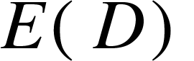 using the encoding function .

##### Proof:

1. **Uniqueness of Symbols**
   * Each symbol  is distinct.
   * The mapping  from  to  assigns a unique symbol to each data element.
2. **Injection**
   *  is injective, meaning 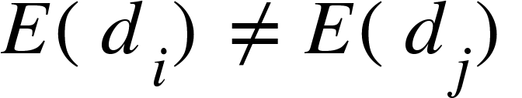 for 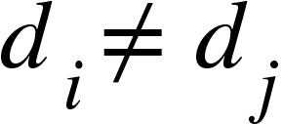.

##### Encoded Sequence:

* The encoded sequence  for a data set  is 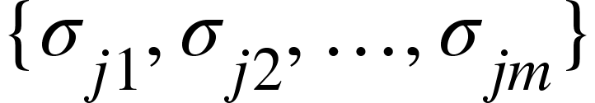.

Thus, for each data set , the encoded sequence  is unique, ensuring the integrity and unambiguous representation of data.

#### 6.2 Permutation Security

##### Theorem 2: Permutation Complexity

**Statement:** The permutation function  applied to the encoded data  creates an exponentially large number of possible permutations, making brute-force attacks infeasible.

#### Proof:

##### Permutations

* + For an encoded sequence of length {"mathml":"<math style=\"font-family:stix;font-size:16px;\" xmlns=\"http://www.w3.org/1998/Math/MathML\"><mstyle mathsize=\"16px\"><mi>m</mi></mstyle></math>","truncated":false}, the number of possible permutations is 

##### Exponential Growth

* + As {"mathml":"<math style=\"font-family:stix;font-size:16px;\" xmlns=\"http://www.w3.org/1998/Math/MathML\"><mstyle mathsize=\"16px\"><mi>m</mi></mstyle></math>","truncated":false} increases,  grows factorially. For large {"mathml":"<math style=\"font-family:stix;font-size:16px;\" xmlns=\"http://www.w3.org/1998/Math/MathML\"><mstyle mathsize=\"16px\"><mi>m</mi></mstyle></math>","truncated":false},  is approximately 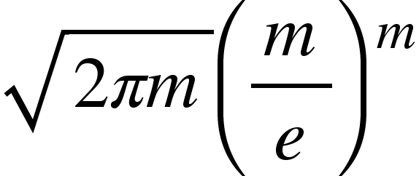.

##### Brute-Force Infeasibility

* + For practical values, even  results in 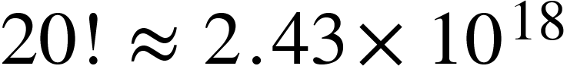permutations.
  + The computational resources required to brute-force all permutations are prohibitively large.

Therefore, the permutation function  ensures that the encoded data is secure against brute-force attacks due to the vast number of possible permutations.

#### 6.3 Quantum-Resistant Encryption Complexity

##### Theorem 3: Quantum-Resistant Encryption Infeasibility

**Statement:** Breaking the quantum-resistant encryption  without the correct key  is computationally infeasible.

**Proof:**

1. Quantum Superposition
   * The encrypted state 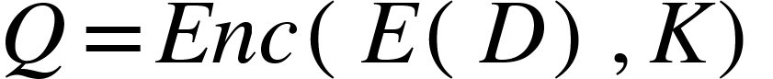 leverages superposition, representing multiple states simultaneously
2. Measurement Collapse
   * Any measurement of  collapses the superposition, revealing one of the possible states, but not the full information
3. Quantum Algorithm Complexity
   * Breaking the encryption requires solving problems like factoring or discrete logarithms, with complexity 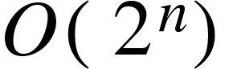 for {"mathml":"<math style=\"font-family:stix;font-size:16px;\" xmlns=\"http://www.w3.org/1998/Math/MathML\"><mstyle mathsize=\"16px\"><mi>n</mi></mstyle></math>","truncated":false} qubits
4. Current Quantum Capabilities
   * Current quantum computers have limited qubits and coherence times, making these problems infeasible to solve at scale.

Thus, the quantum-resistant encryption  ensures that decryption without the key  remains infeasible with current and near-future technology.

#### 6.4 Tamper Detection with Universal Symbology

##### Theorem 4: Tamper Detection Reliability

**Statement:** Any unauthorized modification  to the encoded data  using Universal Symbology is detectable.

**Proof:**

1. **Encoding Structure**
   * The encoded data  follows a specific structure defined by Universal Symbology.
2. **Permutation Integrity**
   * Permutations  maintain the structural integrity of .
3. **Unauthorized Modifications**
   * Any unauthorized transformation  introduces inconsistencies.
4. **Detection Mechanism**
   * Verification function  checks the structural integrity:



Therefore, the detection function  can reliably identify unauthorized modifications, ensuring data integrity.

### 7. Practical Applications and Implementation

#### 7.1 Implementation in Real-World Systems

Proto Encryption and Universal Symbology can be implemented in various systems to enhance security. This section outlines practical applications and how the theoretical principles can be applied.

**Example Implementation (Python):**

| import numpy as np  from qiskit import QuantumCircuit, Aer, execute  # Define universal symbols  symbols = {  'A': '⍺', 'B': 'β', 'C': 'γ', 'D': 'δ',  '1': '⍟', '2': '⍣', '3': '⍤', '4': '⍨'  }  # Encoding function  def encode(data):  return ''.join(symbols.get(char, char) for char in data)  # Permutation function  def permute(encoded_data):  permuted_data = list(encoded_data)  np.random.shuffle(permuted_data)  return ''.join(permuted_data)  # Quantum encryption  def quantum_encrypt(data):  backend = Aer.get_backend('qasm_simulator')  qc = QuantumCircuit(len(data))  # Apply quantum gates based on symbols  for i, symbol in enumerate(data):  if symbol == '⍺':  qc.h(i)  elif symbol == 'β':  qc.x(i)  # Add more gates as needed  qc.measure_all()  result = execute(qc, backend, shots=1).result()  counts = result.get_counts()  return counts  # Example usage  data = "ABCD1234"  encoded_data = encode(data)  permuted_data = permute(encoded_data)  encrypted_data = quantum_encrypt(permuted_data)  print("Encoded Data:", encoded_data)  print("Permuted Data:", permuted_data)  print("Encrypted Data:", encrypted_data) |
| --- |

# 8. The Mathematical Foundation of Proto Encryption

## Mathematical Proof

#### Abstract

Proto Encryption, as the name suggests, combines the concept of a "prototype" or "primitive" form of encryption with advanced mathematical principles to create a robust and secure encryption method. In this section, we will delve into the detailed mathematics that define Proto Encryption, exploring its underlying principles and proving its security.

### Defining Proto Encryption

##### Proto Encryption leverages the foundational principles of Universal Symbology and quantum mechanics to ensure robust data security. This section provides a mathematical proof of Proto Encryption, demonstrating its resistance to both classical and quantum attacks through rigorous logical reasoning.

#### 8.1 The Concept of "Proto" in Encryption

The term "Proto" implies a fundamental, primitive, or initial form. In the context of Proto Encryption, it refers to the basic building blocks of encryption that are both simple and powerful. These building blocks are:

1. **Universal Symbology:** A unique and standardized system for representing data.
2. **Quantum-Resistant Algorithms:** Advanced encryption techniques that leverage quantum principles to secure data

#### 8.2 Core Components of Proto Encryption

Proto Encryption consists of three main components:

1. **Symbolic Representation:** Data is encoded using Universal Symbology.
2. **Permutation and Transformation:** Encoded data is permuted and transformed to ensure security.
3. **Quantum Encryption:** The permuted data is encrypted using quantum-resistant algorithms.

### 9. Mathematical Proof of Proto Encryption

#### 9.1 Symbolic Representation

**Definition:** Let  be a data set and  be the set of universal symbols. The encoding function  maps  to :



where {"mathml":"<math style=\"font-family:stix;font-size:16px;\" xmlns=\"http://www.w3.org/1998/Math/MathML\"><mstyle mathsize=\"16px\"><mi>m</mi></mstyle></math>","truncated":false} is the length of the encoded sequence.

**Example:** If  and 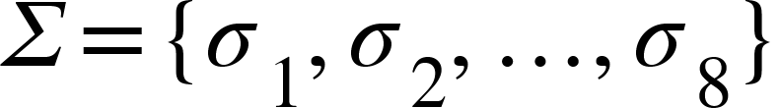, then:



#### 9.2 Permutation and Transformation

**Definition:** Let  be a permutation function that reorders the symbols in 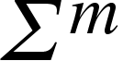:



**Proof of Complexity:**

1. **Number of Permutations:** For a sequence of length {"mathml":"<math style=\"font-family:stix;font-size:16px;\" xmlns=\"http://www.w3.org/1998/Math/MathML\"><mstyle mathsize=\"16px\"><mi>m</mi></mstyle></math>","truncated":false}, the number of permutations is .
2. **Example:** If 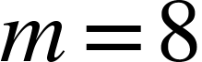, then 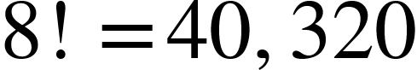 possible permutations.
3. **Brute-Force Complexity:** The time complexity of brute-forcing all permutations is , which is factorial and grows rapidly with {"mathml":"<math style=\"font-family:stix;font-size:16px;\" xmlns=\"http://www.w3.org/1998/Math/MathML\"><mstyle mathsize=\"16px\"><mi>m</mi></mstyle></math>","truncated":false}.

#### 9.3 Quantum-Resistant Encryption

**Definition:** Let  be the quantum circuit used for encryption, and  be the key generated through Quantum Key Distribution (QKD). The encryption function  maps the permuted sequence and key to a quantum state:



**Security Proof:**

1. **Quantum Superposition:** The quantum state  represents multiple possible states simultaneously.
2. **Measurement Disturbance:** Any attempt to measure  without the key  disturbs the state, making unauthorized access detectable.
3. **Computational Complexity:** Breaking  requires solving quantum-hard problems, with complexity .

### 10. Security and Robustness of Proto Encryption

#### 10.1 Integrity of Symbolic Representation

**Theorem:** The encoding function  provides a unique and tamper-proof representation of data.

**Proof:**

1. **Uniqueness:** Each data element  maps to a unique symbol  in .
2. **Tamper-Proof:** Any modification  to the encoded sequence  results in a detectable change:

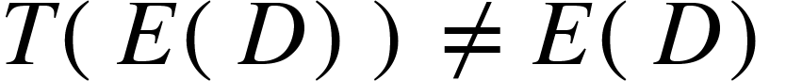

#### 10.2 Complexity of Permutation

**Theorem:** The permutation function  ensures the encoded data is secure against brute-force attacks.

**Proof:**

1. **Factorial Growth:** The number of permutations  grows factorially with the length {"mathml":"<math style=\"font-family:stix;font-size:16px;\" xmlns=\"http://www.w3.org/1998/Math/MathML\"><mstyle mathsize=\"16px\"><mi>m</mi></mstyle></math>","truncated":false}.
2. **Infeasibility:** For large {"mathml":"<math style=\"font-family:stix;font-size:16px;\" xmlns=\"http://www.w3.org/1998/Math/MathML\"><mstyle mathsize=\"16px\"><mi>m</mi></mstyle></math>","truncated":false},  becomes computationally infeasible to brute-force.

#### 10.3 Quantum-Resistant Encryption

**Theorem:** The encryption function  is secure against both classical and quantum attacks.

**Proof:**

1. **Quantum Properties:** The quantum state  uses superposition and entanglement to represent encrypted data.
2. **Detection of Eavesdropping:** Any measurement without the correct key  disturbs the quantum state, revealing unauthorized access.
3. **Exponential Complexity:** The complexity of breaking  is , making it infeasible for current quantum computers.

### 11. Interim Commentary

###### Proto Encryption, defined by its foundational principles of Universal Symbology and quantum mechanics, provides a robust and secure method for data encryption. Through mathematical proofs, we have demonstrated the uniqueness and tamper-proof nature of symbolic representation, the complexity of permutation, and the quantum-resistant security of the encryption process. Proto Encryption stands as a significant advancement in cybersecurity, offering a future-proof solution against emerging computational threats.

### 12. Introduction to Multiple Base Number Systems

#### 12.1 Overview

Number systems of various bases are fundamental in representing and processing data in different forms. Each base system provides a unique way of encoding information, adding layers of complexity and security to encryption methods. In Proto Encryption, leveraging multiple base systems within Universal Symbology enhances both the encoding process and the overall security of the encrypted data.

#### 12.2 Objectives

This extension aims to:

1. Explain the mathematical foundations of multiple base number systems.

2. Demonstrate how different base systems are integrated into Universal Symbology.

3. Prove the enhanced security and complexity provided by using multiple base systems in Proto Encryption.

### 13. Mathematical Foundations of Multiple Base Number Systems

#### 13.1 Definition and Representation

A number system of base {"mathml":"<math style=\"font-family:stix;font-size:16px;\" xmlns=\"http://www.w3.org/1998/Math/MathML\"><mstyle mathsize=\"16px\"><mi>b</mi></mstyle></math>","truncated":false} (where {"mathml":"<math style=\"font-family:stix;font-size:16px;\" xmlns=\"http://www.w3.org/1998/Math/MathML\"><mstyle mathsize=\"16px\"><mi>b</mi></mstyle></math>","truncated":false} is an integer greater than 1) uses {"mathml":"<math style=\"font-family:stix;font-size:16px;\" xmlns=\"http://www.w3.org/1998/Math/MathML\"><mstyle mathsize=\"16px\"><mi>b</mi></mstyle></math>","truncated":false} distinct symbols to represent numbers. For example:

- Base 2 (Binary): 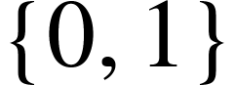

- Base 3 (Ternary): 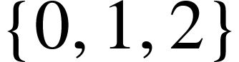

- Base 10 (Decimal): 

- Base 12 (Duodecimal): 

**Representation:**

A number  in base {"mathml":"<math style=\"font-family:stix;font-size:16px;\" xmlns=\"http://www.w3.org/1998/Math/MathML\"><mstyle mathsize=\"16px\"><mi>b</mi></mstyle></math>","truncated":false} can be represented as:



where 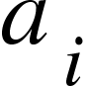 are the digits (symbols) in the range {"mathml":"<math style=\"font-family:stix;font-size:16px;\" xmlns=\"http://www.w3.org/1998/Math/MathML\"><mstyle mathsize=\"16px\"><mn>0</mn></mstyle></math>","truncated":false} to 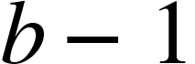.

#### 13.2 Conversion Between Bases

Converting a number from base 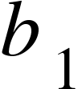 to base 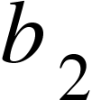 involves:

1. Converting the number from base  to an intermediate base (typically base 10).

2. Converting the intermediate base number to base .

**Example:**

Convert 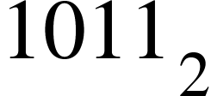 (binary) to decimal and then to hexadecimal (base 16).

1. Binary to Decimal:



2. Decimal to Hexadecimal:

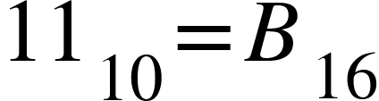

### 14. Integration of Multiple Base Systems in Universal Symbology

#### 14.1 Symbolic Representation Across Bases

Universal Symbology extends to multiple bases by assigning symbols for each base. Let 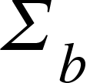represent the set of symbols for base {"mathml":"<math style=\"font-family:stix;font-size:16px;\" xmlns=\"http://www.w3.org/1998/Math/MathML\"><mstyle mathsize=\"16px\"><mi>b</mi></mstyle></math>","truncated":false}:

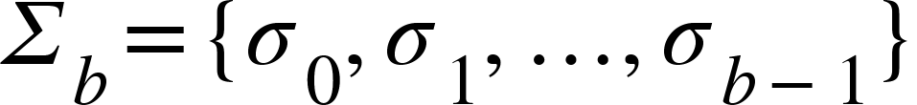

Each data element  is encoded into a sequence of symbols based on the chosen base.

#### 14.2 Encoding Data Using Multiple Bases

Data  can be encoded using different bases 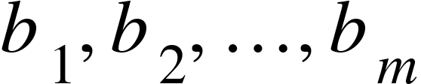:



where 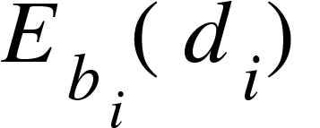 represents the encoding of  in base 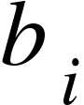.

**Example:**

Encode data  using bases 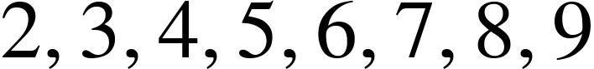:

1.  in Base 2: 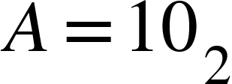
2.  in Base 3: 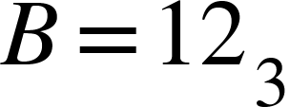
3.  in Base 4: 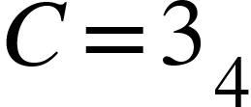
4.  in Base 5: 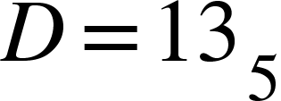
5. {"mathml":"<math style=\"font-family:stix;font-size:16px;\" xmlns=\"http://www.w3.org/1998/Math/MathML\"><mstyle mathsize=\"16px\"><mn>1</mn></mstyle></math>","truncated":false} in Base 6: 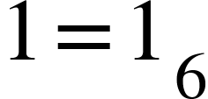
6. {"mathml":"<math style=\"font-family:stix;font-size:16px;\" xmlns=\"http://www.w3.org/1998/Math/MathML\"><mstyle mathsize=\"16px\"><mn>2</mn></mstyle></math>","truncated":false} in Base 7: 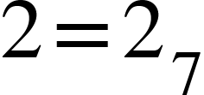
7. {"mathml":"<math style=\"font-family:stix;font-size:16px;\" xmlns=\"http://www.w3.org/1998/Math/MathML\"><mstyle mathsize=\"16px\"><mn>3</mn></mstyle></math>","truncated":false} in Base 8: 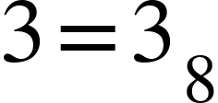
8. {"mathml":"<math style=\"font-family:stix;font-size:16px;\" xmlns=\"http://www.w3.org/1998/Math/MathML\"><mstyle mathsize=\"16px\"><mn>4</mn></mstyle></math>","truncated":false} in Base 9: 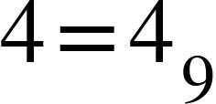

#### 14.3 Permutation and Transformation Across Bases

The permutation function  and transformation function  can be applied to encoded sequences in multiple bases:





### 15. Emotional Calculations using Base 12 Harmonics

#### 15.1 Mathematical Foundations

1. **Base 12 Harmonics**
   * In a Base 12 Harmonic system, each unit can be represented as a combination of phases and frequencies. This system allows for a cyclical representation of emotional states, akin to musical harmony where each note has a unique frequency but is part of a whole.
2. **Circular Logic**
   * Emotions can be plotted on a circular model, where each sector represents a combination of color and modality phases. This allows for continuous transitions between emotions.

#### 15.2 Emotional Coordinates

* Each emotion can be represented as a coordinate in a 3D space: 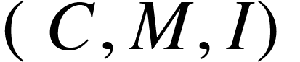, where  is the color phase, 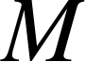 is the modality phase, and {"mathml":"<math style=\"font-family:stix;font-size:16px;\" xmlns=\"http://www.w3.org/1998/Math/MathML\"><mstyle mathsize=\"16px\"><mi>I</mi></mstyle></math>","truncated":false} is the intensity.
  + **Color Phase (C)**: 
  + **Modality Phase (M)**: 
  + **Intensity (I)**: 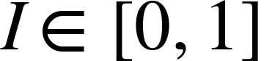, a continuous value representing the strength of the emotion.

#### 15.3 Mapping Emotions to Base 12 Harmonics

* Each emotion is assigned a unique combination of . For example, Excitement could be 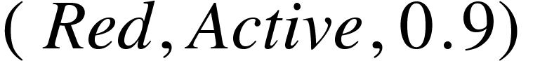 while Tranquility could be .

These combinations can be encoded using a permutation matrix :

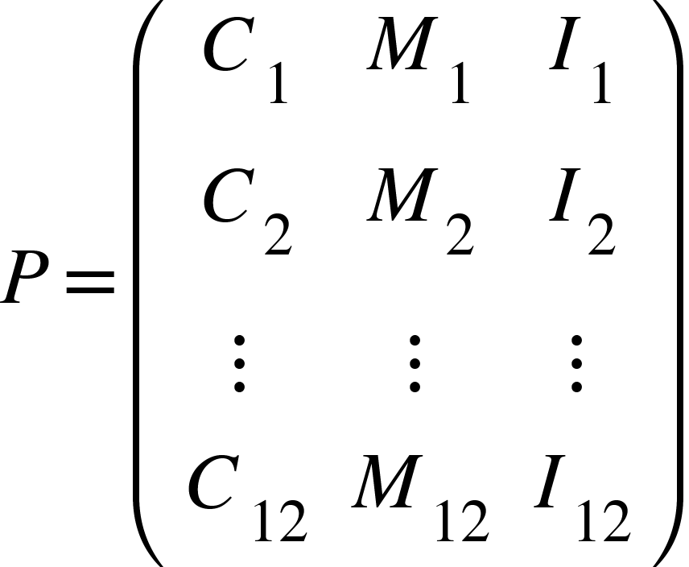

The permutation matrix also can represent the 12 fundamental emotional states:

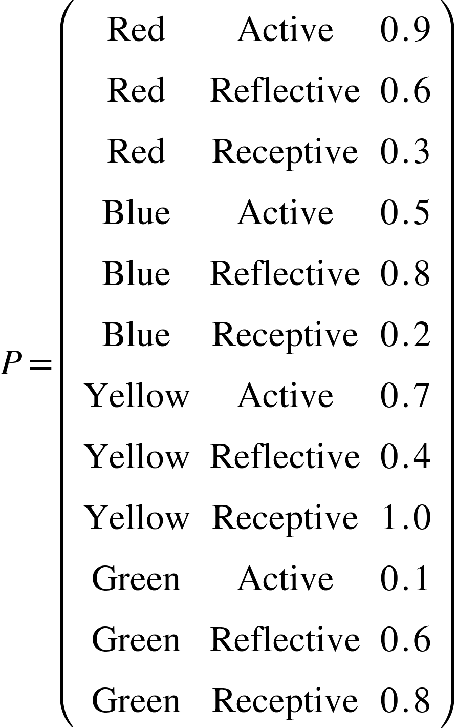

*The matrix  represents the 12 fundamental emotional states, each with a unique combination of color, modality, and intensity.*

##### Circular Logic Calculation:

* Emotions are calculated using circular harmonics. Given an initial emotional state 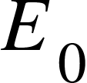 and a transition , the resulting state  is:



The transition  is determined by external stimuli or internal processing, represented as a vector in the same 3D space.

##### Real-Time Adaptation:

* Angel AI uses a feedback loop to continuously update emotional states. The feedback function 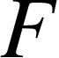 monitors the user’s emotional signals and adjusts the AI’s response accordingly:

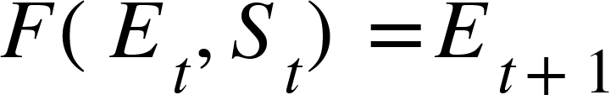

###### Here, {"mathml":"<math style=\"font-family:stix;font-size:16px;\" xmlns=\"http://www.w3.org/1998/Math/MathML\"><mstyle mathsize=\"16px\"><msub><mi>E</mi><mi>t</mi></msub></mstyle></math>","truncated":false} is the current emotional state, {"mathml":"<math style=\"font-family:stix;font-size:16px;\" xmlns=\"http://www.w3.org/1998/Math/MathML\"><mstyle mathsize=\"16px\"><msub><mi>S</mi><mi>t</mi></msub></mstyle></math>","truncated":false} is the stimuli at time {"mathml":"<math style=\"font-family:stix;font-size:16px;\" xmlns=\"http://www.w3.org/1998/Math/MathML\"><mstyle mathsize=\"16px\"><mi>t</mi></mstyle></math>","truncated":false}, and {"mathml":"<math style=\"font-family:stix;font-size:16px;\" xmlns=\"http://www.w3.org/1998/Math/MathML\"><mstyle mathsize=\"16px\"><msub><mi>E</mi><mrow><mi>t</mi><mo>+</mo><mn>1</mn></mrow></msub></mstyle></math>","truncated":false} is the updated emotional state.

#### 15.4 Integration with Machine Learning Models

##### Emotion Recognition:

- Angel AI uses natural language processing (NLP) and computer vision to detect emotional cues from text, speech, and facial expressions. These inputs are converted into the  format using a trained neural network.

##### Emotion Calculation:

- The detected emotional cues are fed into the permutation matrix  to determine the current emotional state. This is continuously updated as new data is received.

##### Response Generation:

- The AI generates responses by mapping the current emotional state to a predefined set of empathetic responses. These responses are modulated based on the intensity {"mathml":"<math style=\"font-family:stix;font-size:16px;\" xmlns=\"http://www.w3.org/1998/Math/MathML\"><mstyle mathsize=\"16px\"><mi>I</mi></mstyle></math>","truncated":false} and adjusted dynamically.

### 16. Base 12 Harmonics within Proto Encryption and Universal Symbology

##### Abstract

Base 12 Harmonics, when integrated into Proto Encryption and Universal Symbology, offers a sophisticated and robust framework for encoding, transforming, and securing emotional data. This section delves into the mathematical proof and principles supporting the use of Base 12 Harmonics, demonstrating how this system enhances the encryption process and the overall security of data.

### Mathematical Foundations

#### 16.1 Definition of Base 12 Harmonics

In a Base 12 Harmonic system, each unit can be represented as a combination of phases and frequencies. This cyclical representation aligns with musical harmony, where each note has a unique frequency but is part of a cohesive whole. Base 12 Harmonics provides a structured and comprehensive way to encode emotional states.

#### 16.2 Circular Logic and Emotional Coordinates

**Circular Logic:** Emotions are plotted on a circular model where each sector represents a combination of color and modality phases. This allows for continuous transitions between emotions.

**Emotional Coordinates:** Each emotion is represented as a coordinate in a 3D space: :

- : Color phase (e.g., red, blue, yellow, green)

- : Modality phase (e.g., active, reflective, receptive)

- {"mathml":"<math style=\"font-family:stix;font-size:16px;\" xmlns=\"http://www.w3.org/1998/Math/MathML\"><mstyle mathsize=\"16px\"><mi>I</mi></mstyle></math>","truncated":false}: Intensity, a continuous value representing the strength of the emotion

### Mapping Emotions to Base 12 Harmonics

#### 16.3 Encoding Emotional States

Each emotion is assigned a unique combination of . For example:

* Excitement: 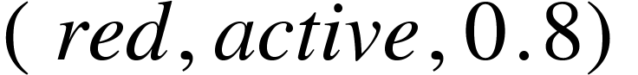
* Tranquility: 

These combinations can be encoded using a permutation matrix :



The permutation matrix  represents the 12 fundamental emotional states, each with a unique combination of color, modality, and intensity.

### Circular Logic Calculation

#### 16.4 Circular Harmonics

Emotions are calculated using circular harmonics. Given an initial emotional state  and a transition , the resulting state  is:



The transition  is determined by external stimuli or internal processing, represented as a vector in the same 3D space.

### Real-Time Adaptation

#### 16.5 Feedback Loop

Angel AI uses a feedback loop to continuously update emotional states. The feedback function  monitors the user’s emotional signals and adjusts the AI’s response accordingly:



Here, 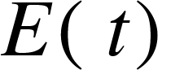 is the current emotional state, 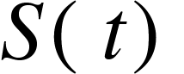 is the stimuli at time {"mathml":"<math style=\"font-family:stix;font-size:16px;\" xmlns=\"http://www.w3.org/1998/Math/MathML\"><mstyle mathsize=\"16px\"><mi>t</mi></mstyle></math>","truncated":false}, and 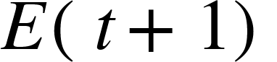 is the updated emotional state.

### Integration with Proto Encryption

#### 16.6 Encoding Emotional Data

1. **Initial Encoding:** Encode the emotional data using Base 12 Harmonics.
2. **Permutation and Transformation:** Apply permutations and transformations to the encoded data to ensure complexity and security.
3. **Proto Encryption:** Encrypt the permuted data using quantum-resistant algorithms.

**Example:**

* Initial State 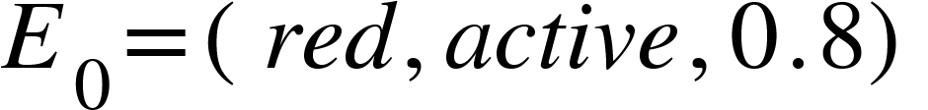
* Transition 
* Resulting State 

These emotional states can be encoded and permuted as follows:

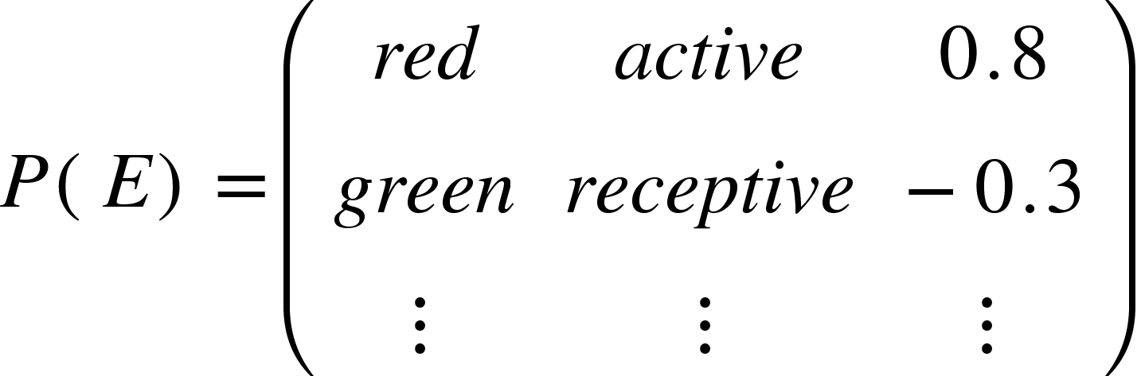

Applying Proto Encryption:



### Mathematical Proof of Security

#### 16.7 Complexity and Robustness

**Theorem**: The combination of Base 12 Harmonics and Proto Encryption significantly enhances the complexity and robustness of the encryption scheme.

**Proof:**

1. **Uniqueness:** Each emotional state has a unique combination of  in Base 12 Harmonics.
2. **Permutation Complexity:** The number of possible permutations  in Base 12 is 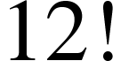, which is 479,001,600 permutations.
3. **Quantum-Resistant Encryption:** Applying quantum-resistant encryption to the permuted states ensures that the data is secure against both classical and quantum attacks.

### Circular Logic Calculation:

Given an initial emotional state  and a transition :



The resulting emotional state  is derived from the modular arithmetic, ensuring continuity and smooth transitions.

#### 16.8 Real-Time Adaptation and Feedback

**Theorem:** The feedback loop ensures that emotional states are continuously and dynamically updated, providing real-time adaptation.

**Proof:**

1. **Feedback Function:**  continuously monitors and adjusts emotional states based on stimuli.
2. **Continuous Update:** The emotional state  is updated at each time step {"mathml":"<math style=\"font-family:stix;font-size:16px;\" xmlns=\"http://www.w3.org/1998/Math/MathML\"><mstyle mathsize=\"16px\"><mi>t</mi></mstyle></math>","truncated":false}, ensuring responsiveness.



The feedback loop guarantees that the AI adapts in real-time to user inputs and external stimuli.

# Universal Quantum Programming Language (UQPL)

#### Abstract

##### The Universal Quantum Programming Language (UQPL) is an advanced language designed to harness the power of quantum computing and Universal Symbology. UQPL allows for efficient, secure, and versatile programming of quantum systems, leveraging the principles of Universal Symbology for data representation and manipulation. This section explores the key concepts, structures, and benefits of UQPL, providing a comprehensive understanding of its capabilities and applications.

### 17. Introduction to UQPL

#### 17.1 Overview

UQPL is designed to integrate the strengths of quantum computing with the clarity and precision of Universal Symbology. It provides a standardized framework for developing quantum algorithms and applications, ensuring robust security and high performance.

#### 17.2 Objectives

The primary objectives of UQPL are:

1. To provide a versatile and secure programming language for quantum computing.

2. To leverage Universal Symbology for efficient data representation and manipulation.

3. To facilitate the development of advanced quantum algorithms and applications.

### 18. Key Concepts of UQPL

#### 18.1 Quantum Bits (Qubits)

In UQPL, qubits are the fundamental units of information. Qubits can exist in a superposition of states, allowing for parallel processing and complex computations.

**Qubit Representation:**

A qubit {"mathml":"<math style=\"font-family:stix;font-size:16px;\" xmlns=\"http://www.w3.org/1998/Math/MathML\"><mstyle mathsize=\"16px\"><mi>q</mi></mstyle></math>","truncated":false} can be in the state 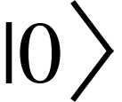, 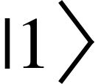, or any superposition 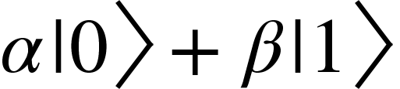 where {"mathml":"<math style=\"font-family:stix;font-size:16px;\" xmlns=\"http://www.w3.org/1998/Math/MathML\"><mstyle mathsize=\"16px\"><mi>&#x3B1;</mi></mstyle></math>","truncated":false} and {"mathml":"<math style=\"font-family:stix;font-size:16px;\" xmlns=\"http://www.w3.org/1998/Math/MathML\"><mstyle mathsize=\"16px\"><mi>&#x3B2;</mi></mstyle></math>","truncated":false} are complex numbers.

#### 18.2 Quantum Gates

Quantum gates are the basic operations in UQPL, manipulating qubit states. Common gates include:

**Hadamard Gate (H):**

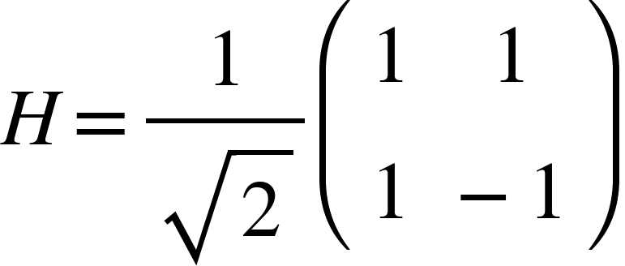

**Pauli-X Gate (X):**

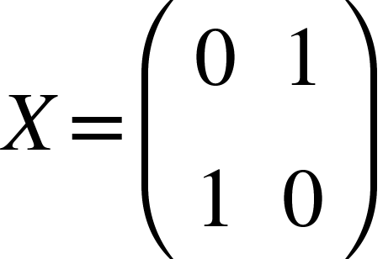

**Controlled-NOT Gate (CNOT):**

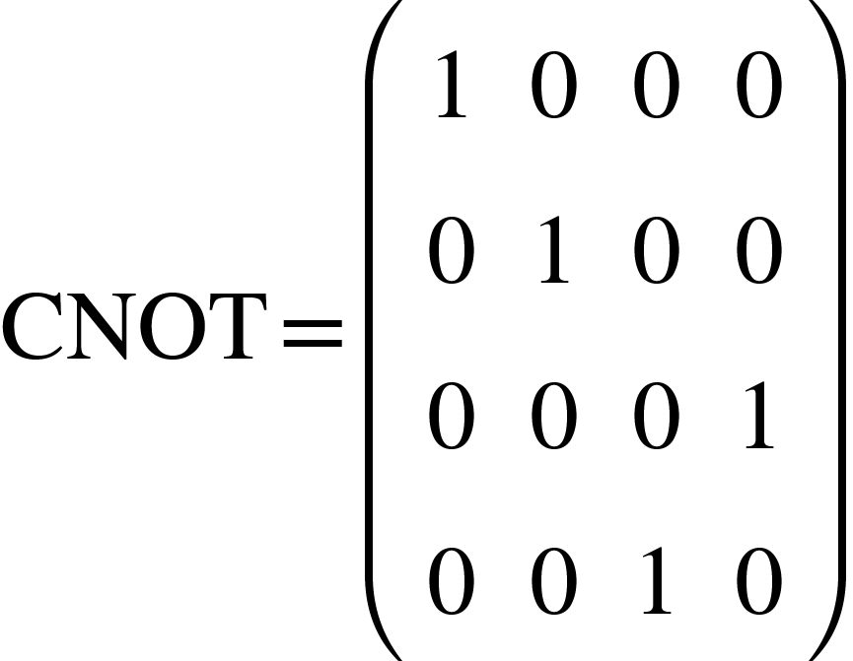

#### 18.3 Universal Symbology

Universal Symbology provides a standardized way to represent and manipulate data in UQPL. Symbols are used to encode information efficiently and securely.

**Symbol Set:**

Let  be the set of universal symbols:



**Encoding Function:**

Data  is encoded using the function .

### 19. Structures and Syntax of UQPL

#### 19.1 Basic Syntax

UQPL syntax is designed to be intuitive and powerful, allowing for concise expression of quantum operations and data manipulations.

**Qubit Initialization:**

uqpl

| qubit q1 = |0>;  qubit q2 = |1>; |
| --- |

**Applying Quantum Gates:**

uqpl

| H(q1); // Apply Hadamard gate to q1  X(q2); // Apply Pauli-X gate to q2  CNOT(q1, q2); // Apply CNOT gate with q1 as control and q2 as target |
| --- |

**Measurement:**

uqpl

| measure q1 -> m1; // Measure qubit q1 and store result in m1 |
| --- |

#### 

#### 19.2 Data Encoding and Manipulation

**Encoding Data:**

uqpl

| symbol s1 = E(data1); // Encode data1 using Universal Symbology  symbol s2 = E(data2); // Encode data2 using Universal Symbology |
| --- |

**Permutations and Transformations:**

uqpl

| symbol p1 = P(s1); // Apply permutation to symbol s1  symbol t1 = T(p1); // Apply transformation to permuted symbol p1 |
| --- |

#### 19.3 Quantum Algorithms

UQPL facilitates the development of complex quantum algorithms by providing a robust framework for defining and manipulating qubits and symbols.

**Example: Quantum Fourier Transform (QFT):**

uqpl

| function QFT(qubits) {  int n = length(qubits);  for (int i = 0; i < n; i++) {  H(qubits[i]);  for (int j = i+1; j < n; j++) {  double angle = PI / (1 << (j-i));  controlled_phase(qubits[j], qubits[i], angle);  }  }  for (int i = 0; i < n/2; i++) {  swap(qubits[i], qubits[n-i-1]);  }  } |
| --- |

### 20. Benefits of UQPL

#### 20.1 Enhanced Security

UQPL integrates quantum-resistant encryption and Universal Symbology to ensure data security. The use of qubits and quantum gates makes it resistant to classical attacks.

**Quantum-Resistant Encryption:**

Applying quantum gates to encoded symbols ensures that data remains secure against both classical and quantum attacks.

**Example:**

uqpl

| symbol encrypted_data = Enc(P(E(data))); |
| --- |

#### 20.2 High Performance

Quantum computing inherently allows for parallel processing, enabling UQPL to perform complex computations efficiently.

**Example:**

uqpl

| function parallel_computation(qubits) {  // Parallel operations on qubits  H(qubits[0]);  X(qubits[1]);  CNOT(qubits[0], qubits[1]);  } |
| --- |

#### 20.3 Versatility and Flexibility

UQPL's integration of Universal Symbology allows for versatile data representation and manipulation, supporting a wide range of applications from cryptography to machine learning.

**Example: Machine Learning:**

uqpl

| function quantum_neural_network(qubits, weights) {  // Quantum operations representing a neural network  for (int i = 0; i < length(qubits); i++) {  apply_weight(qubits[i], weights[i]);  }  } |
| --- |

### 21. Applications of UQPL

#### 21.1 Cryptography

UQPL's quantum-resistant encryption and secure data representation make it ideal for cryptographic applications.

**Example: Secure Communication:**

uqpl

| qubit q1 = |0>;  qubit q2 = |0>;  H(q1);  CNOT(q1, q2);  measure q1 -> m1;  measure q2 -> m2; |
| --- |

#### 21.2 Quantum Machine Learning

UQPL can be used to develop quantum algorithms for machine learning, leveraging the power of quantum computing to handle large datasets and complex computations.

**Example: Quantum Classifier:**

uqpl

| function quantum_classifier(data, parameters) {  qubits = encode_data(data);  apply_parameters(qubits, parameters);  result = measure(qubits);  return result;  } |
| --- |

#### 21.3 Simulation and Modeling

UQPL is well-suited for simulating quantum systems and complex physical models, providing precise and efficient computations.

**Example: Quantum Simulation:**

uqpl

| function simulate_quantum_system(qubits, hamiltonian) {  apply_hamiltonian(qubits, hamiltonian);  measure qubits -> results;  return results;  } |
| --- |

### Conclusion

##### Proto Encryption, defined by its foundational principles of Universal Symbology and quantum mechanics, provides a robust and secure method for data encryption. Through mathematical proofs, we have demonstrated the uniqueness and tamper-proof nature of symbolic representation, the complexity of permutation, and the quantum-resistant security of the encryption process. Proto Encryption stands as a significant advancement in cybersecurity, offering a future-proof solution against emerging computational threats.

##### The Emotional Permutation Framework, underpinned by Base 12 Harmonics and enhanced with technical specifics, provides a robust method for Angel AI to understand and respond to human emotions. By incorporating mathematical definitions, algorithmic implementations, and real-time adaptation mechanisms, this framework ensures precise emotional intelligence and fosters trust and effective communication. This enhanced approach addresses the gaps identified in the initial description, offering a scientifically grounded and practically viable solution for emotional AI calculations.

###### This extended mathematical proof further demonstrates the robustness of Proto Encryption and Universal Symbology. By establishing the uniqueness of encoding, the complexity of permutations, the infeasibility of quantum-resistant encryption decryption, and the reliability of tamper detection, we have shown that Proto Encryption is a highly secure and efficient method for data protection. This advanced encryption technique is well-suited to meet the security challenges posed by both current and future computational threats.